Datum: 08.01.2021
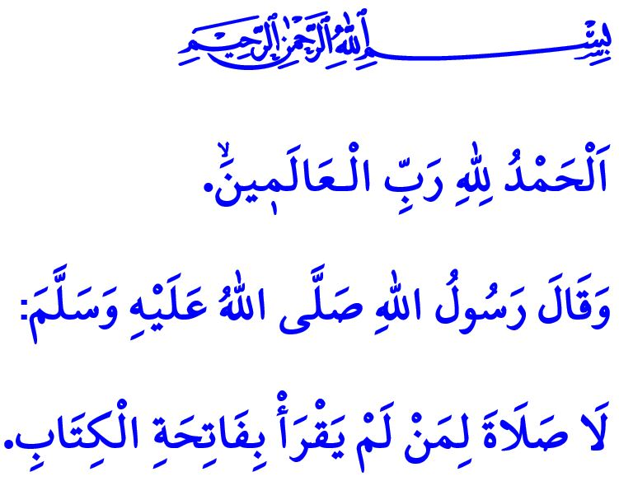
SURAH AL-FATIHA: THE OPENER AND PREFACE OF THE QUR’AN
Honorable Muslims!
One day Prophet Muhammad said to one of his companions, Abu Sa’id ibn al-Mualla: “Shall I teach you the greatest surah in the Qur’an before you leave the masjid?” After the prayer as they left the masjid, he (saw) said: “It is the Surah al-Fatiha that consists of seven verses and is recited repeatedly during prayers.”
Dear Believers!
The Surah al-Fatiha is the preface of our divine book the Holy Qur’an. We recite this surah in every rakat of our prayers as Prophet Muhammad once said, “If anyone observes prayer in which he does not recite the Surah al-Fatiha, his prayer is deficient and not complete.” Whenever we recite the Surah al-Fatiha, which is a servant’s heartfelt communication with their Lord, we become relieved knowing that Allah the Almighty states, “Whatever My servant wishes shall be granted.”
Dear Muslims!
We start the Surah al-Fatiha by reciting the Basmalah, namely “In the Name of Allah, the Entirely Merciful, the Especially Merciful”. We know that every act initiated without remembering the name of Allah is deficient, incomplete, and lacking of divine abundance of blessings.
Upon reciting the verse, اَلْحَمْدُ لِلّٰهِ رَبِّ الْـعَالَم۪ينَۙ , we extend our endless gratitude, thankfulness, praise and reverence to our Lord (swt), Who is the Creator and Ruler of the universe.
اَلرَّحْمٰنِ الرَّح۪يمِۙ We know that He (swt) is the Entirely Merciful, and the Especially Merciful. His grace and mercy is abundant.
مَالِكِ يَوْمِ الدّ۪ينِۜ He (swt) is the only Sovereign of the Day of Judgment. He (swt) is the Owner of Absolute Justice, Who will make His servants recompense in the Hereafter.
اِيَّاكَ نَعْبُدُ وَاِيَّاكَ نَسْتَع۪ينُۜ It is Him alone we worship and Him we ask for help. For there is no other true authority to seek refuge in, lean on, and trust in.
اِهْدِنَا الصِّرَاطَ الْمُسْتَق۪يمَۙ صِرَاطَ الَّذ۪ينَ اَنْعَمْتَ عَلَيْهِمْۙ
غَيْرِ الْمَغْضُوبِ عَلَيْهِمْ وَلَا الضَّٓالّ۪ينَ
O Allah, our Lord! “Guide us to the straight path, the path of those upon whom You have bestowed favor. Not of those who have earned Your anger or of those who are astray.” Amin!
Dear Believers!
Let us strive with due diligence to recite, comprehend, and live by our Holy Book that opens with al-Fatiha. I would like to take this opportunity to invite all of you to the campaign “Let’s Learn the Qur’an from Home” launched by the Presidency of Religious Affairs of Turkey. You can apply online at the website of the Presidency of Religious Affairs for the campaign, learn to recite the Qur’an with online courses wherever you are, and reflect its light on your family and life. In addition, there are optional and elective courses at schools such as the Holy Qur’an, Prophet Muhammad and His Life, and Basic Islamic Knowledge. Let us encourage our children to select these courses.

Bukhari, Tafsir, (Fatiha), 1.
Bukhari, Adhan, 95.
Muslim, Salat, 38.
Fatiha, 1/1-7. General Directorate of Religious Services

